USER INTERFACE DESIGN

EXPERIMENT 3

ROLL NO:240701044

NAME: ZARAA JUHI SAAI K
Command Line Interface
import random

options = ["rock", "paper", "scissors"] system_choice = random.choice(options)

print("🎮 Rock Paper Scissors - CLI Version") print("Choices: rock / paper / scissors")

user_choice = input("Enter your choice: ").lower()

ifuser_choice not in options: print("❌ Invalid choice")
else:
print(f"Computer chose: {system_choice}")

ifuser_choice == system_choice: print("🤝 It's a tie!")
elif(user_choice == "rock" and system_choice == "scissors") or \ (user_choice == "paper" and system_choice == "rock") or \ (user_choice == "scissors" and system_choice == "paper"): print("🎉 You win!")
else:
print("😢 You lose!")

OUTPUT:
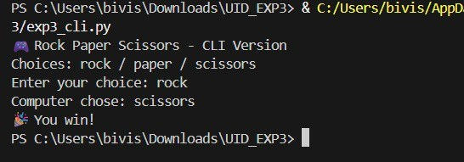

Graphical User Interface
import tkinter as tk import random
from tkinter import messagebox

choices = ["rock", "paper", "scissors"]

defplay_game(user_pick):
computer_pick = random.choice(choices)

ifuser_pick == computer_pick: result = "It's a Tie!"
elif(user_pick == "rock" and computer_pick == "scissors") or \ (user_pick == "paper" and computer_pick == "rock") or \ (user_pick == "scissors" and computer_pick == "paper"): result = "You Win!"
else:
result = "You Lose!"

messagebox.showinfo( "Result",
f"You chose: {user_pick}\nComputer chose:
{computer_pick}\n\n{result}"
)

window = tk.Tk()
window.title("Rock Paper Scissors") window.geometry("300x250")

tk.Label(window, text="Choose one:").pack(pady=10)

tk.Button(window, text="Rock", width=15, command=lambda: play_game("rock")).pack(pady=5)
tk.Button(window, text="Paper", width=15, command=lambda: play_game("paper")).pack(pady=5)
tk.Button(window, text="Scissors", width=15, command=lambda: play_game("scissors")).pack(pady=5)

window.mainloop()

OUTPUT:

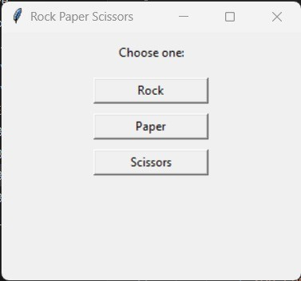
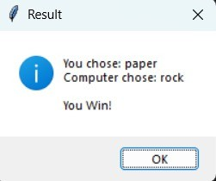

Voice User Interface
import random

import time

choices = ["rock", "paper", "scissors"] computer = random.choice(choices)

print("🎤 Voice Assistant: Rock Paper Scissors") time.sleep(0.5)
print("🔊 Please say rock, paper, or scissors")

whileTrue:
user= input(" 🎧

You: ").lower()

ifuser not in choices:
print("⚠ System: Please say a valid option") continue

print("⏳ System is thinking...") time.sleep(0.5)

print(f"🖥
System chose: {computer}")

ifuser== computer:
print("🤝 System: It's a tie!")
elif(user == "rock" and computer == "scissors") or \ (user == "paper" and computer == "rock") or \ (user == "scissors" and computer == "paper"): print("🎉 System: You win!")
else:
print("😢 System: You lose!") break

OUTPUT:
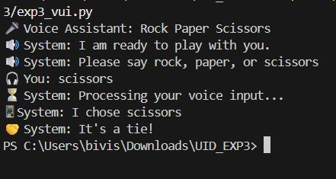

User Satisfaction Comparison

defsurvey(): try:
print("Rate your satisfaction with the following interfaces (1–5):")

cli_satisfaction = int(input("CLI (1-5): ")) gui_satisfaction = int(input("GUI (1-5): ")) vui_satisfaction = int(input("VUI (1-5): "))

print("\nYour satisfaction ratings:") print(f"CLI: {cli_satisfaction}") print(f"GUI: {gui_satisfaction}") print(f"VUI: {vui_satisfaction}")

#Calculate the average satisfaction
avg_satisfaction = (cli_satisfaction + gui_satisfaction + vui_satisfaction) / 3
print(f"\nAverage Satisfaction Score: {avg_satisfaction:.2f}")

except ValueError:
print("Invalid input! Please enter numbers between 1 and 5.")

#Runthe survey function
if name == " main ": survey()

OUTPUT:
